26th April 500 points 40K tournament

A 1 day Warhammer 40000 10th Edition tournament.

Enter the Colosseum and face off against foes to see who will be crowned the Ultimate Champion. 500 points. 1 hour 10 minute rounds

Timings:

* Registration: 09:30 - 10:00
* Game 1: 10:00 – 11:10
* Game 2: 11:15 – 12:25
* Game 3: 12:35 – 13:45
* Lunch: 13:45 – 14:30
* Game 4: 14:30 – 15:40
* Game 5: 15:45 – :16:55
* Game 6: :17:00 – 18:10
* Awards: 18:20

Awards for:

1st place

2nd place

3rd place

Best Sportsman

Best Painted army

Wooden Spoon

Registration

Through Best Coast Pairings:

<https://www.bestcoastpairings.com/event/GiMPBNbe0v8g>

Tickets:

Payments through 7th City Collectables Website:

<https://7thcitycollectables.com/collections/type_play-in-store>

**List Requirements**

* Minimum 1 character as your Warlord
* No epic heroes
* Minimum 2 infantry units that are not your Warlord
* No units Toughness 10 or higher
* Enhancements are allowed
* List maximum is 500 points
* All other standard Pariah Nexus Warhammer 40000 Matched Play list building rules apply

Battlefield

**All rounds will be fought on a custom Colosseum map that is 36” x 36” using the same mission. This format is inspired by PlayOnTabletop’s King of the Colosseum. All credit goes to them.**

There are 4 ruins within the Colosseum and 4 outside. Units can enter the Colosseum either through the gateways or by scaling the outer walls. All ruins provide line of sight and block cover.

**Map Layout can be found on https://www.phoenix40k.co.uk/tournaments-/**

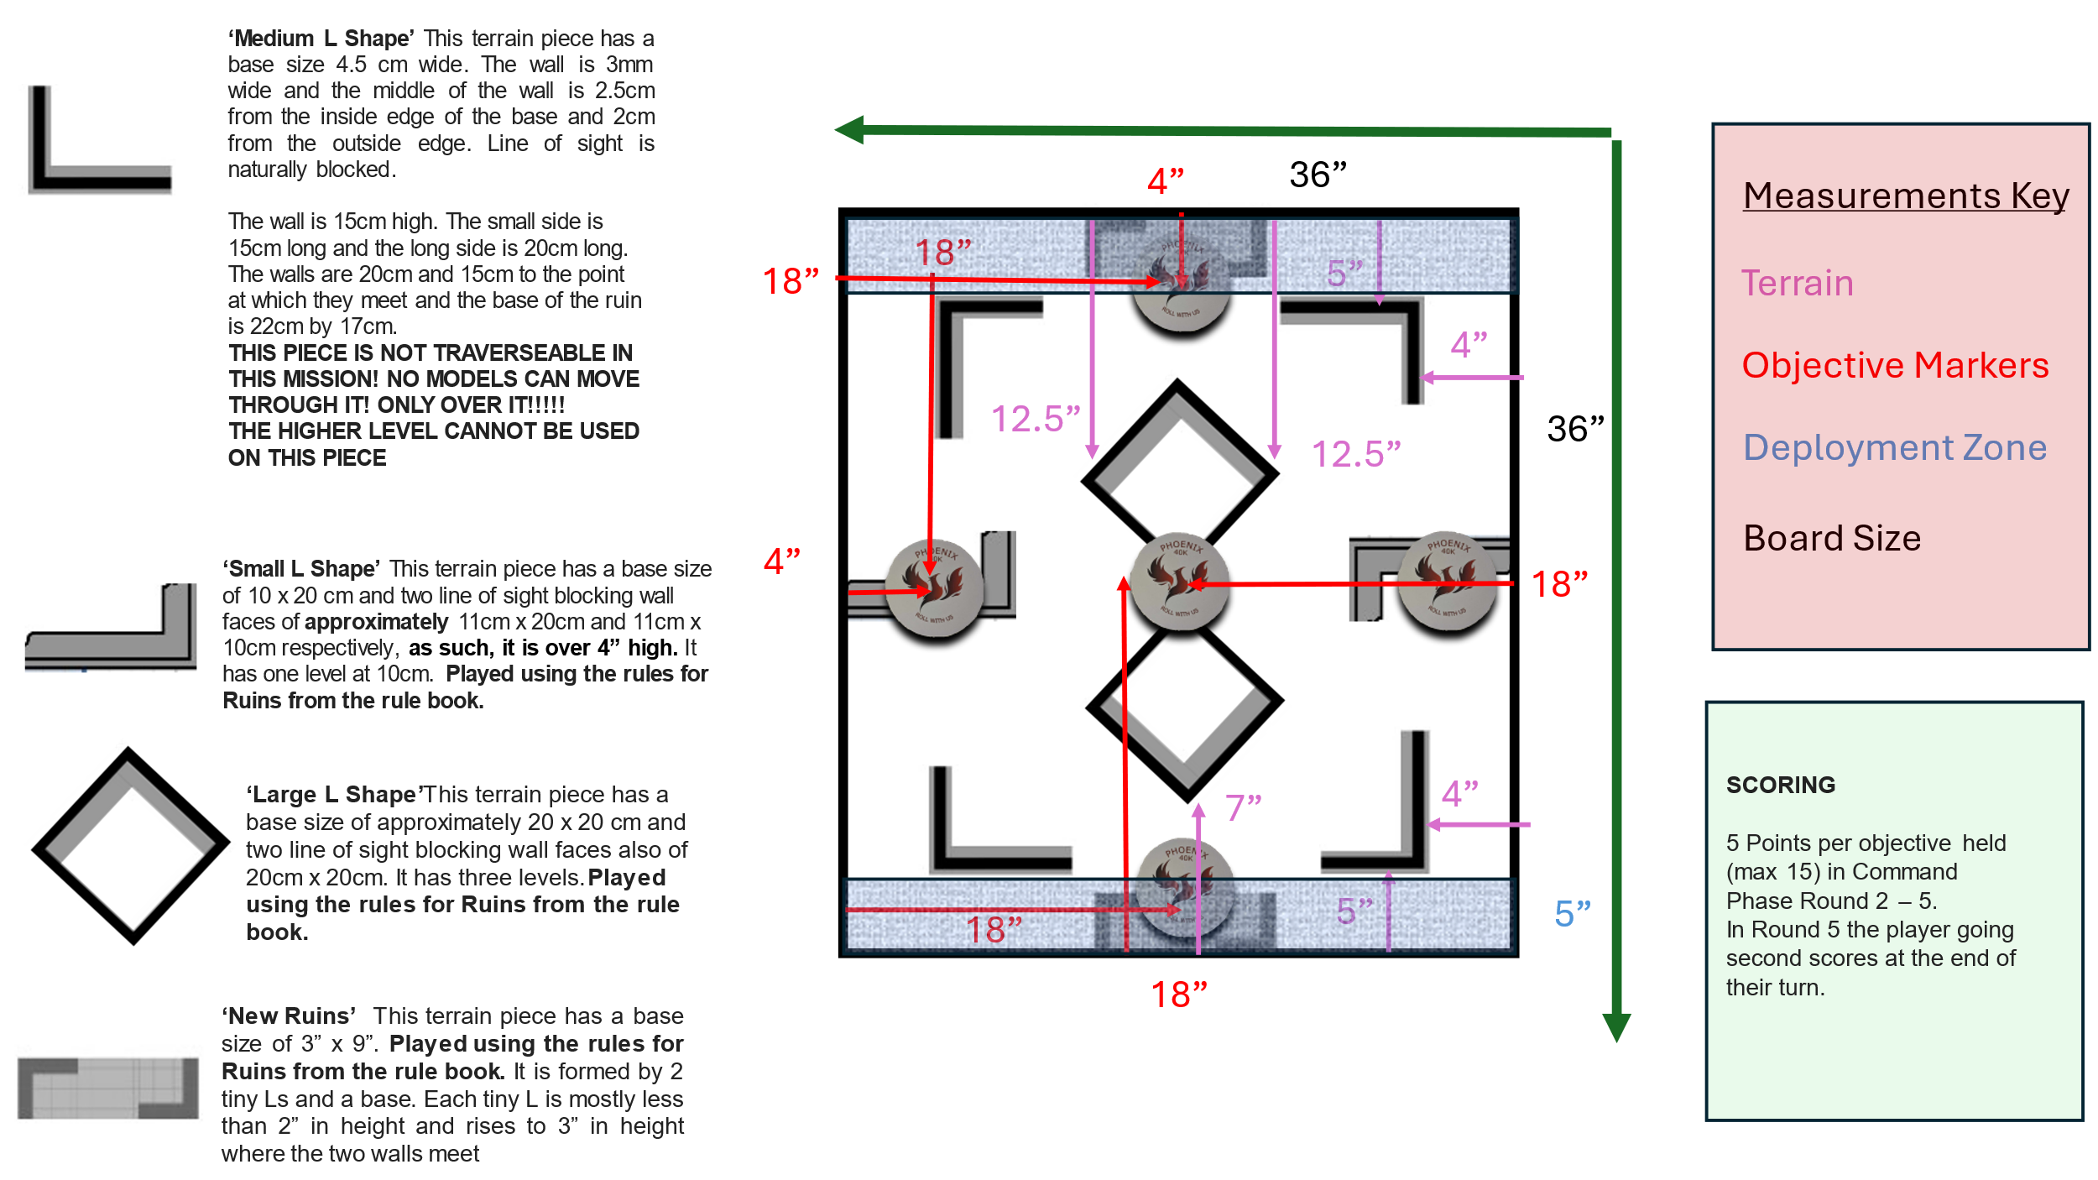

Scoring

Primary:

5 points scored per objective held in Command phase from round 2 onward to a maximum of 15 per round and 50 total for the game.

In the 5th round the player going second scores at the end of their turn.

Secondary:

No secondaries will be used for this event

List Submission

Lists should be submitted by midday the Friday beforehand (11:59 14th March 2025) so they can be checked ahead of time.

Pairings will be assigned using Best Coast Pairings

Please register to allow for smooth uploading of lists and points

<https://www.bestcoastpairings.com/event/GiMPBNbe0v8g>

What do I need to bring:

* A 500 point legal army as per the latest Games Workshop Balance Dataslate and Munitorum Field Manual (<https://www.warhammer-community.com/warhammer-40000-downloads/>) .
* There's no minimum painting requirement, but proxies must be clearly defined as what they are replacing, any queries, drop us a message!
* Dice
* Tape Measure
* Objective Markers
* Any army rules you need
* A good attitude

What is included

* Table fees
* Terrain
* Opponents
* Prizes
* Judging
* Free on site parking
* Lunch

Pairings

Pairings will be assigned using Best Coast Pairings

Please register to allow for smooth uploading of lists and points

<https://www.bestcoastpairings.com/event/GiMPBNbe0v8g>

Scoring

Scoring will be done using the Warhammer 40000 Pariah Nexus Mission Pack

Rulings

The Judge’s word is FINAL!

In the event of a disagreement / accusation of poor sportsmanship / cheating then please call a judge IMMEDIATELY. We cannot help you after the fact, however if you raise the issue straight away then we can probably help resolve it.

Minor rules offences will be given a warning (we all make mistakes).

Intentional cheating can result in penalties ranging from a points penalty between 10-100 points / automatic losses / disqualifications and / or barrings from future events.

Intentional lying, bullying or intimidating behaviour will not be tolerated.

Conceding

Please play out the game as much as possible, you never know, you may be able to turn it around. However, any conceding will assume you score 0 further points for that game from that point on. Please call a Judge to verify this action. In the events of emergencies of course we can be flexible.

Losses

It happens, we all lose, it is part of the game and experience of becoming a better player. Laugh it off, congratulate your opponents and ask for advice.

Terrain and Mission Pack

UKTC rules in place. All rules and copyright relating to UKTC tournament packs belongs to UKTC.

Terrain & Mission pack can be found here:

<https://docs.google.com/document/d/1WV085gGnMPOF-zprcri-9HDW5BWBE34HGc9ndIGRJHM/edit?usp=sharing>

The ground floor of ruins have NO WINDOWS. Upper floors it is true line of sight.

Judges rulings: <https://docs.google.com/document/d/10u4bb4mgqvhFew4MicY4bqnyeZ7Ws57Q6elj95nOPiA/edit?usp=sharing>

Contact

Rulings: [support@phoenix40k.co.uk](mailto:support@phoenix40k.co.uk)

Tickets: [7thcitycollectables@gmail.com](mailto:7thcitycollectables@gmail.com)